A\* search algorithm is one kind of heuristic search method. Heuristic search method is one kind of breadth-first search algorithms. But heuristic searching will follow the node with specific information which might be the best path for achieving the target.

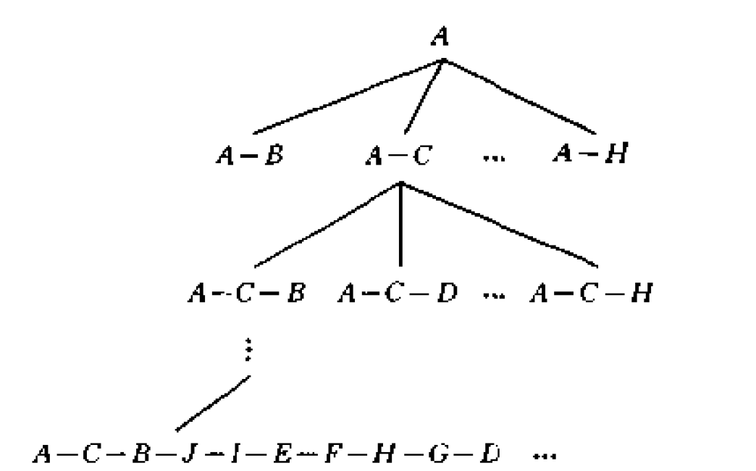

Search tree

First, select the start point as starting node for searching tree. Then expand the point set for sub-node, and keep going we can get every possible path in the bottom of searching tree. In order to reduce the searching space and applying A\* algorithm, we construct the cost function of A\*,

$$f=g+h$$

where *g* is the travel (nodes already visited) cost and *h* is the heuristic function for the cities not been visited yet.

Assume the graph $G=\left(V,E\right)$ which length of segment is given by $length\left(e_{ij}\right)$, $e_{ij}∈E$. The minimum spanning tree of *G* is $T=\left(V,F\right)$, $F∈E$. So,

$$g=f(V,E,c)$$

Where V is the cities that visited and E is the distance between cities, c is the city visit order.

When the visited cities were confirmed, then two end-nodes were known. For the targets that are not visited yet, we add these two end-nodes into these nodes to find a minimum spanning tree. And then calculate h value for left cities.

$$h=f(V,E,cn)$$

where $V$ here is the cities that not visited yet with two end-nodes cities. E is the distance between agent and targets is the order of visiting for not visited cities (minimum spanning tree).

A star is suitable here for agent to find a suitable path to follow to win the game.

Ms. Pac-man can be confused in this situation for she cannot distinguish the venerable ghost status properly and this may cause her chase ghost which killed her.